**Manchester Junior Chess**

**ECF ONLINE UNDER 18 COUNTY CHAMPIONSHIP**

**Saturday 21st November 2020**

**Played on Chess.com**

**Teams will comprise of Two under 18 boys, Two under 18 girls, One under eleven boy and One under 11 girl.**

**There is room for reserves at each level and MJC will ensure that players are rotated in each round so that everyone plays.**

**Swiss Tournament of seven rounds.**

**Time control 10 minutes plus 5 seconds.**

**Players must be registered with an MCF club and be ECF members.**

* INTERESTED CONTACT julian.clissold@outlook.com

**International Tournament**

**Saturday October 31st 2020, the World Cities Day**4.00p.m. to 6.00p.m.  
Location: [lichess.org](https://vk.com/away.php?to=http%3A%2F%2Flichess.org&cc_key=)

**Eligibility:** born in 2002 and younger

ECF Member

Member of MCF Club or school

rating not higher than 1800 FIDE.

No titled players

**Time Control**: 10+5

**Participants from**: Manchester, UK ,St Petersburg Russia, Imatra Finland , Edmonton Canada, Rybnik Poland, Warwickshire,UK

**Interested:** email: julian.clissold@outlook.com

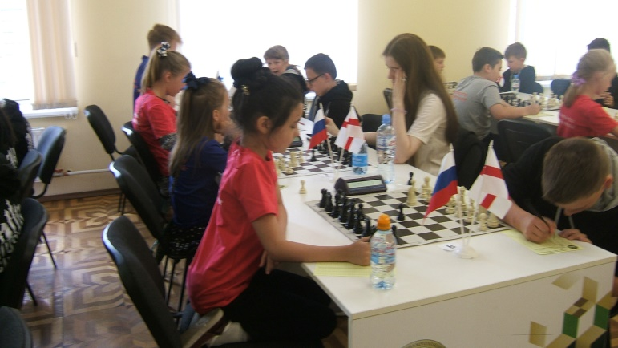

Manchester Juniors vs St Petersburg Juniors 2019